# Binary Classification

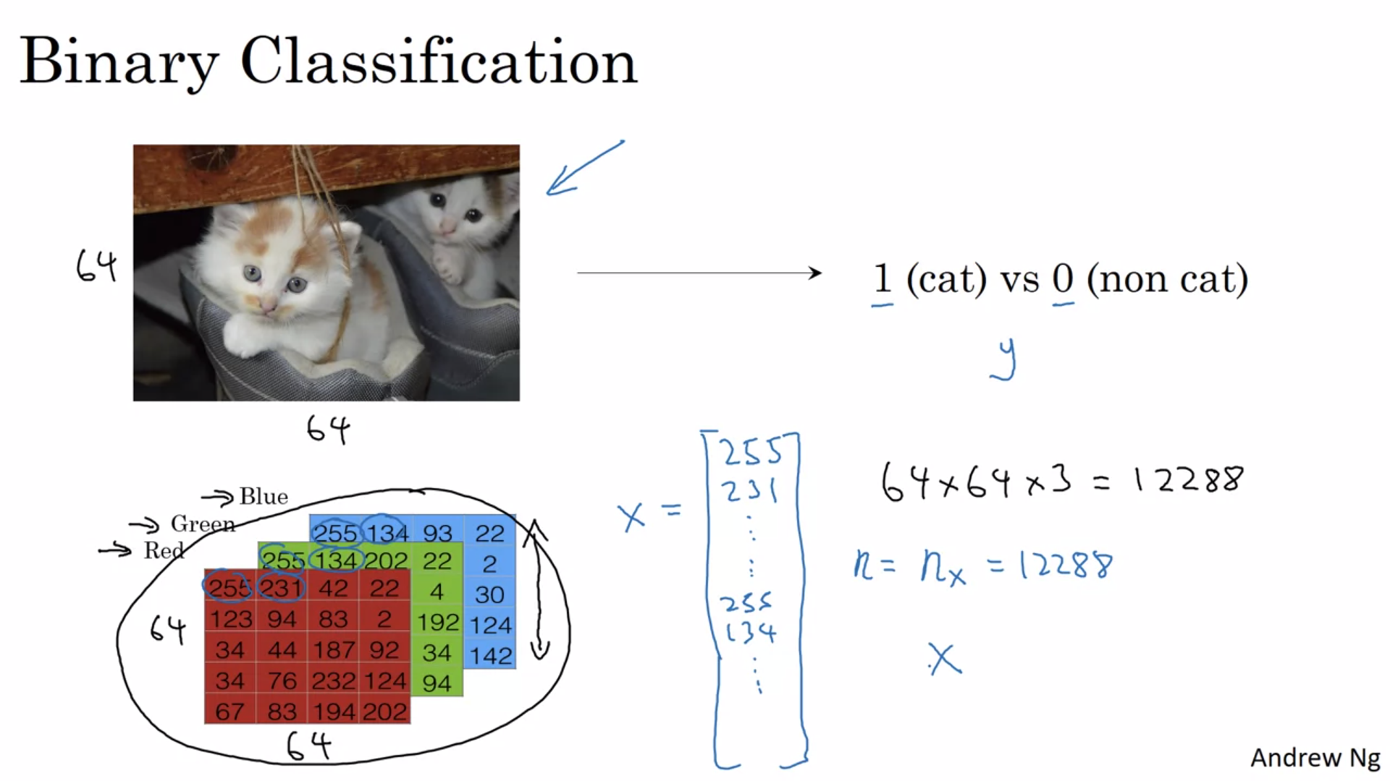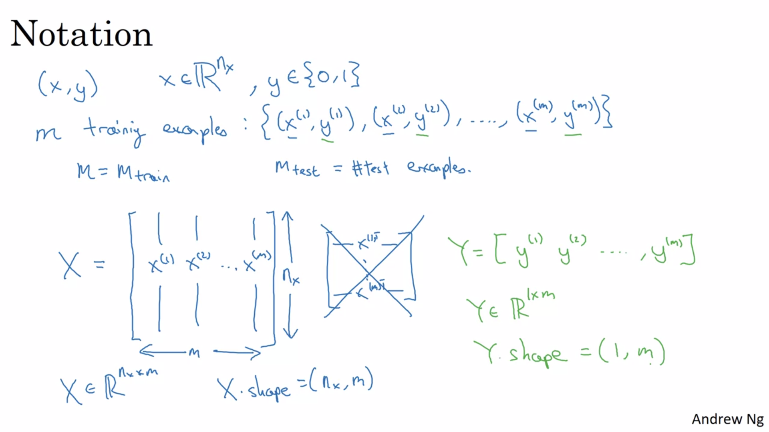

# Logistic Regression

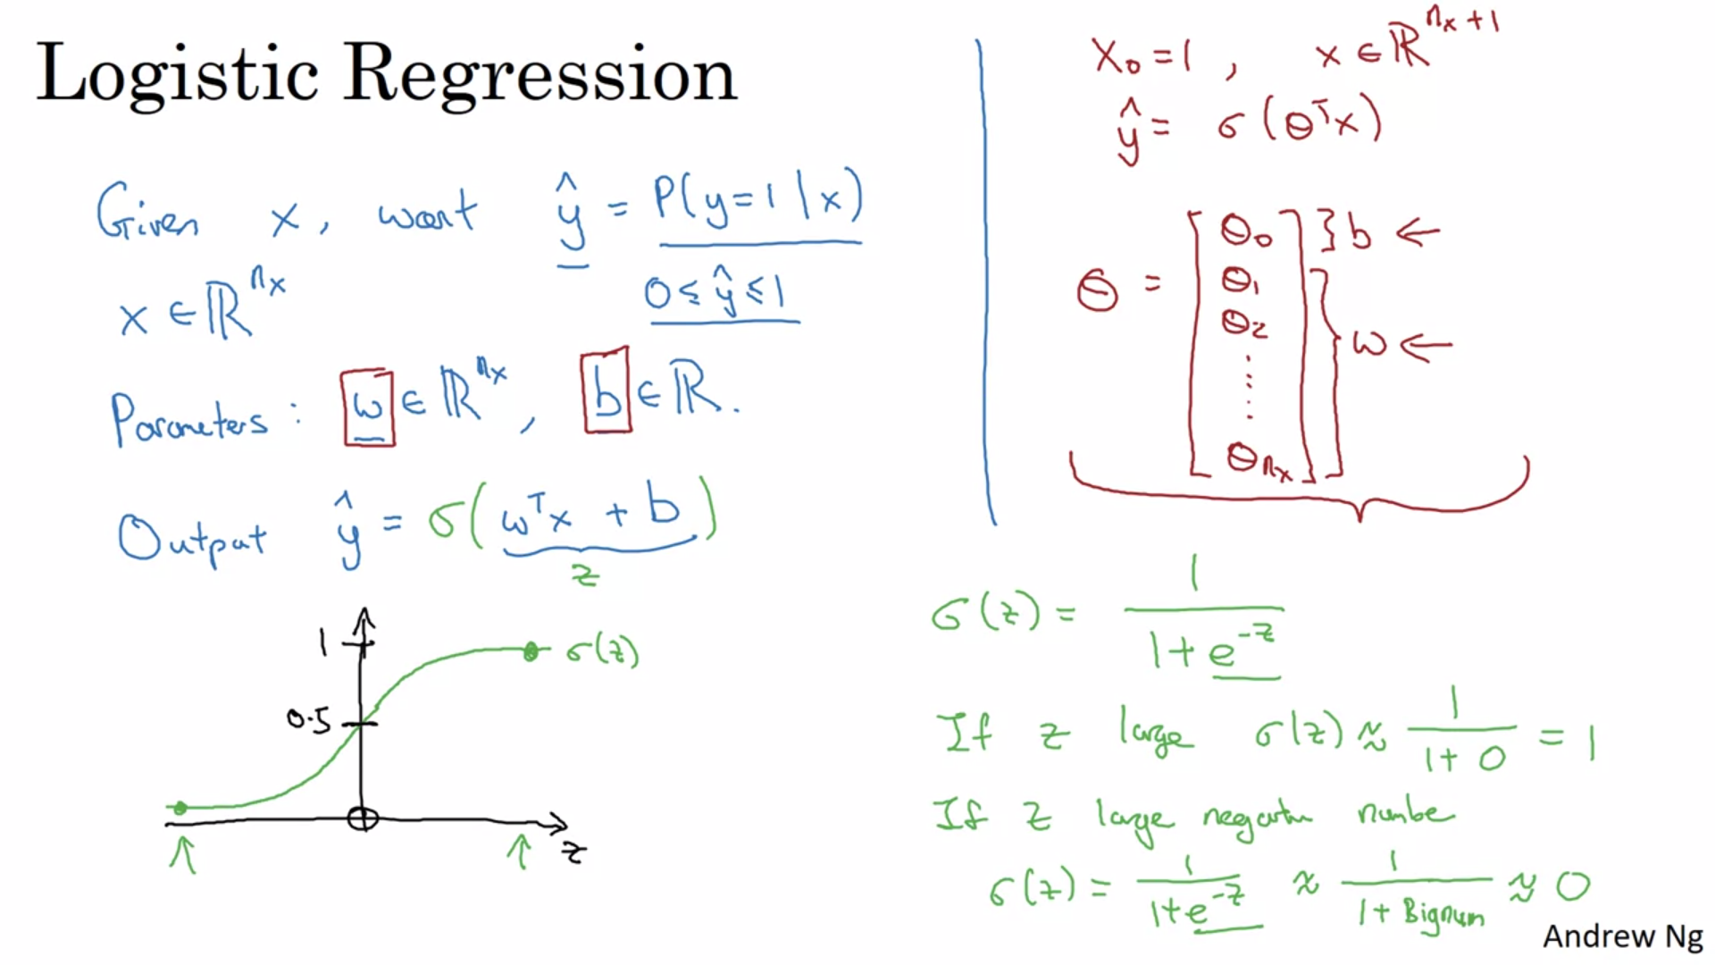

We will not be using notation written in red above (corresponding to theta ) since its observed that keeping parameter terms “w” and “b” separately is helpful in case of neural networks.

# Logistic Regression Cost Function

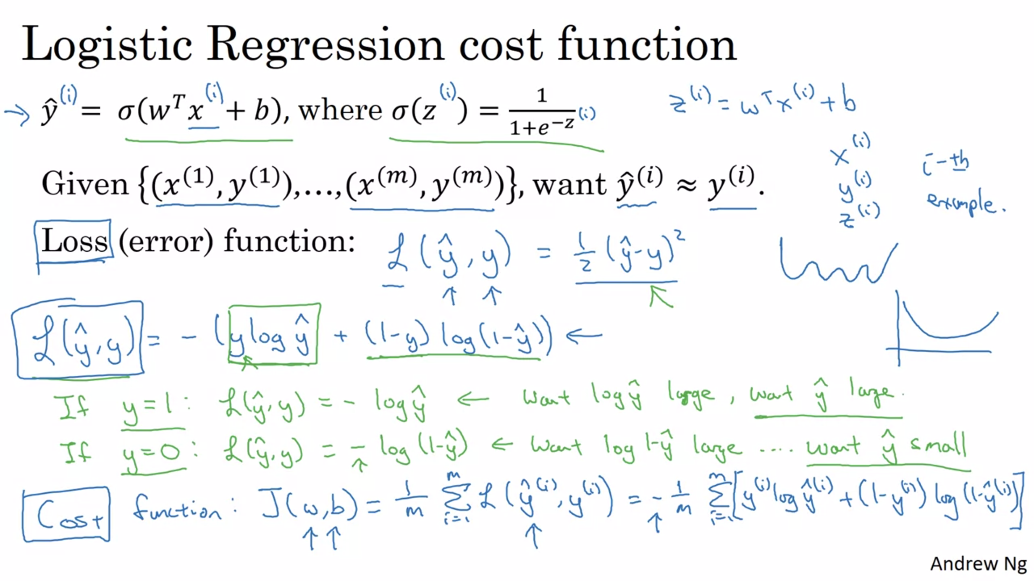

Note- We mentioned loss function as squared error but we don’t use it in logistic regression world since it makes the algorithm non-convex and doesn’t allow gradient descent to find global minima.

The loss function computes the error for a single training example; the cost function is the average of the loss functions of the entire training set.

# Gradient Descent

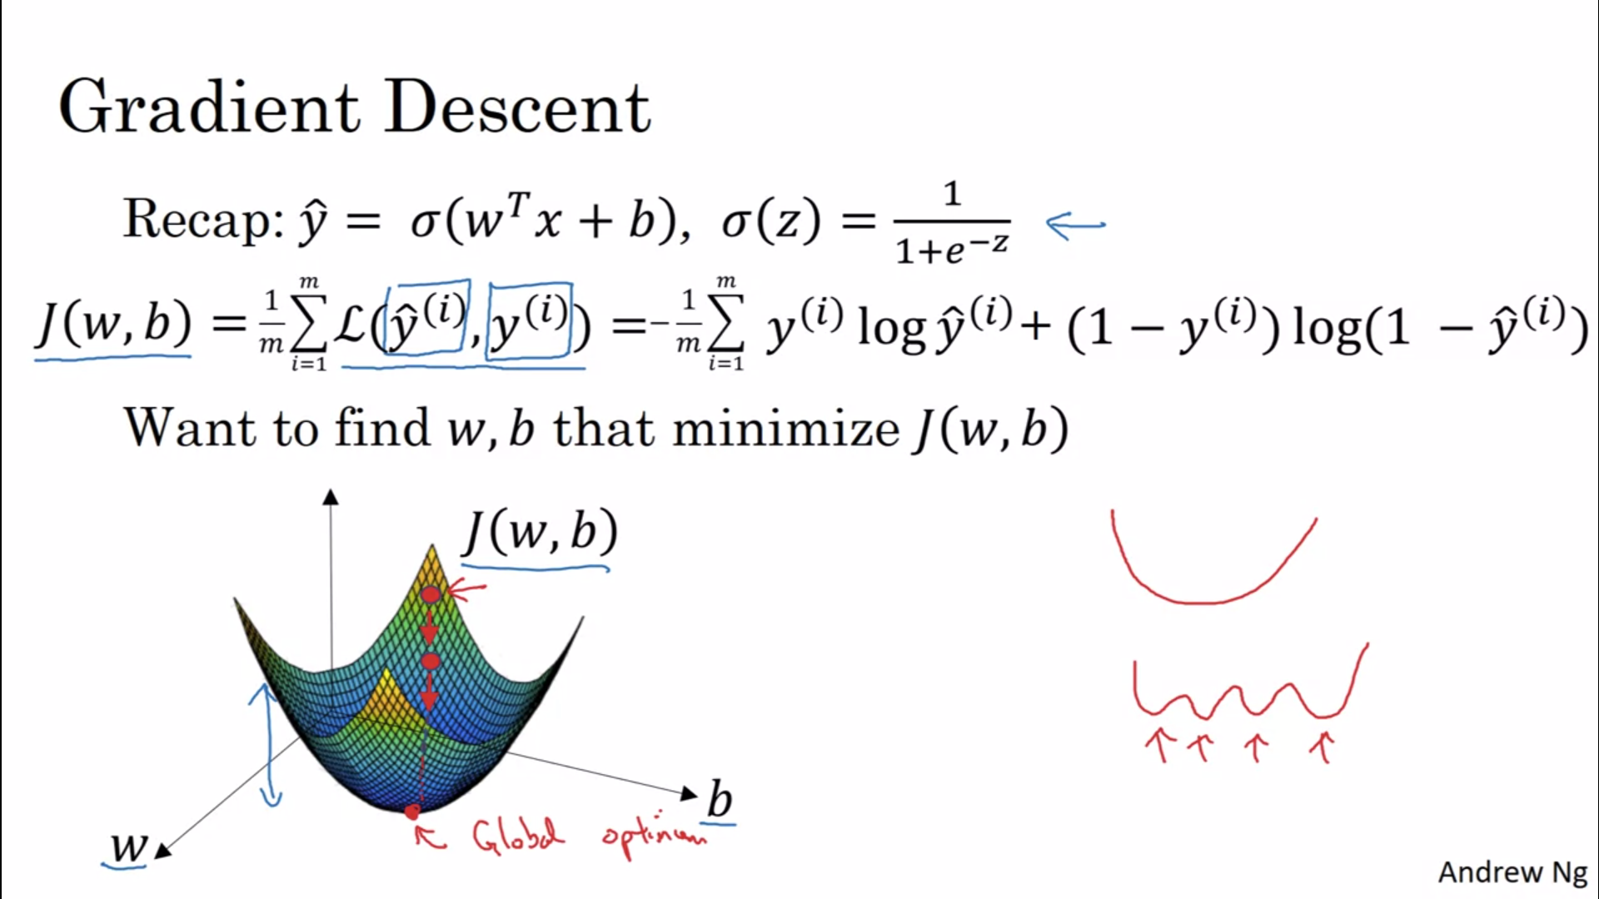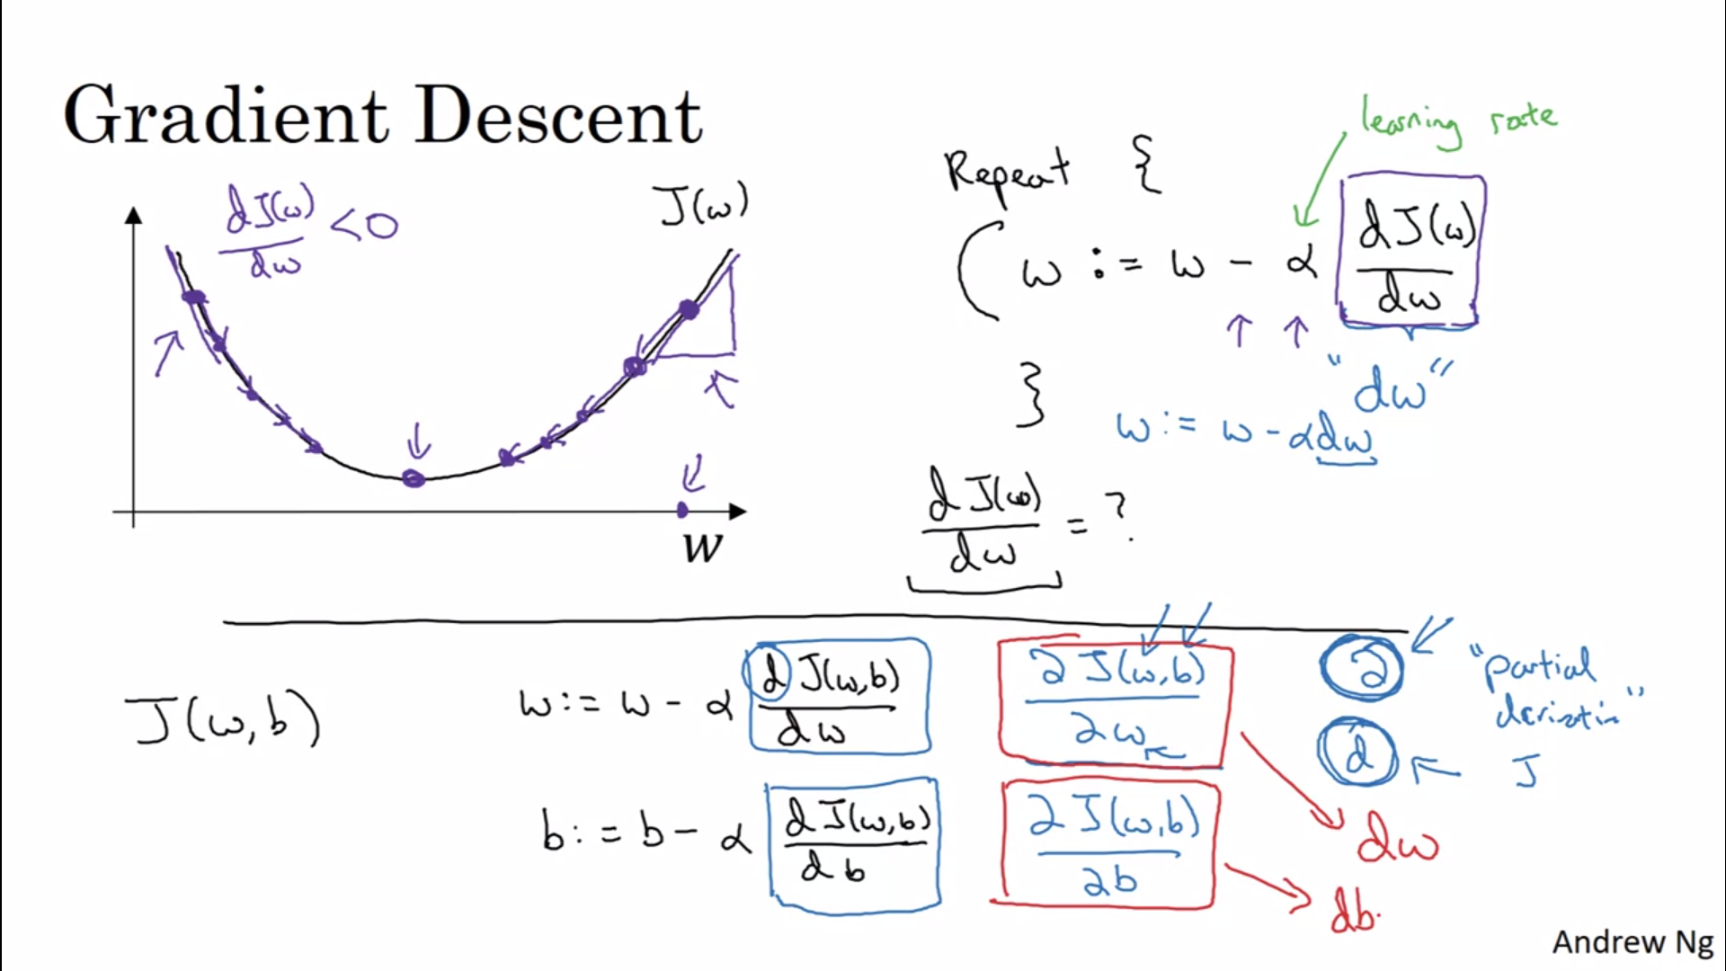

# Derivatives

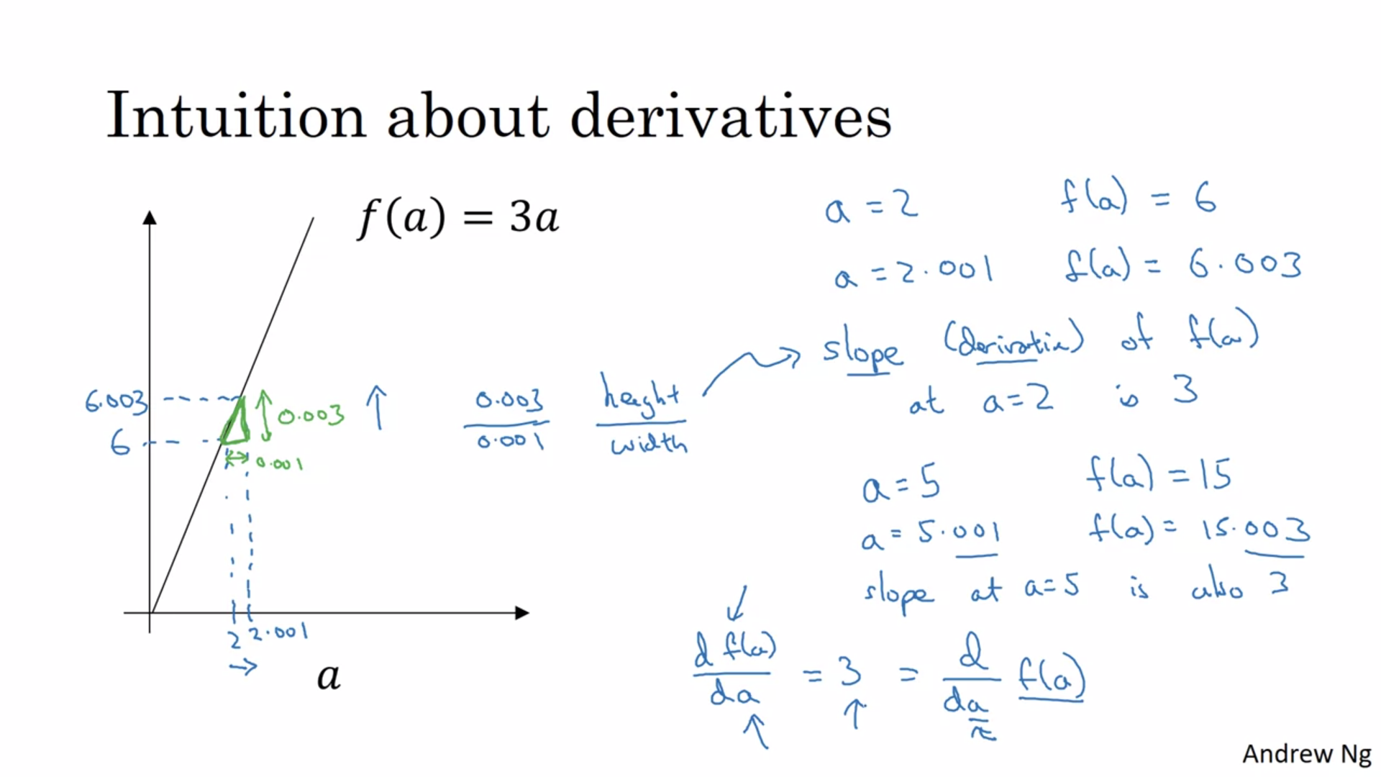

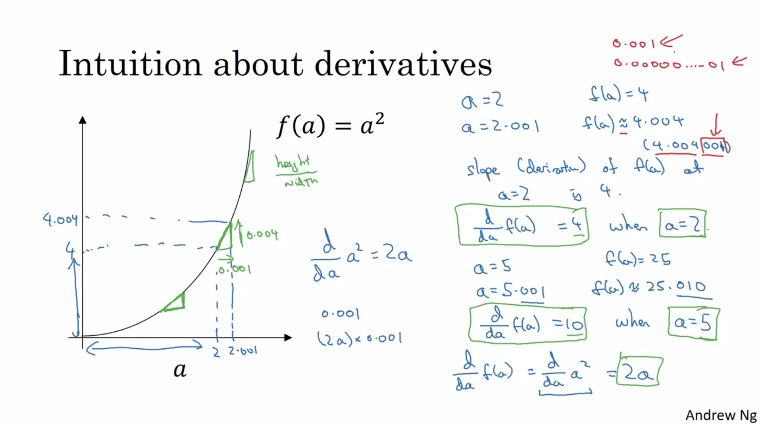

# Computation Graph

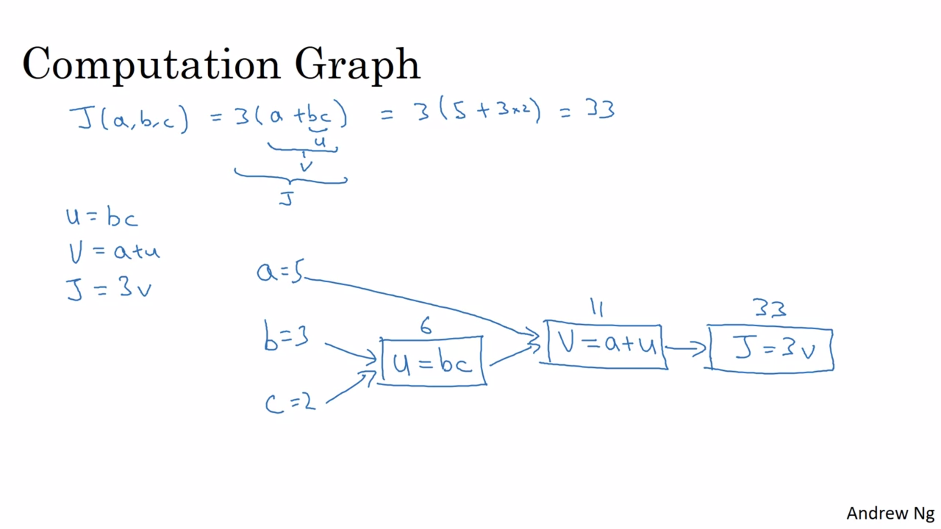

The computation graph organises computation from left to right.

# Derivatives with a computation graph

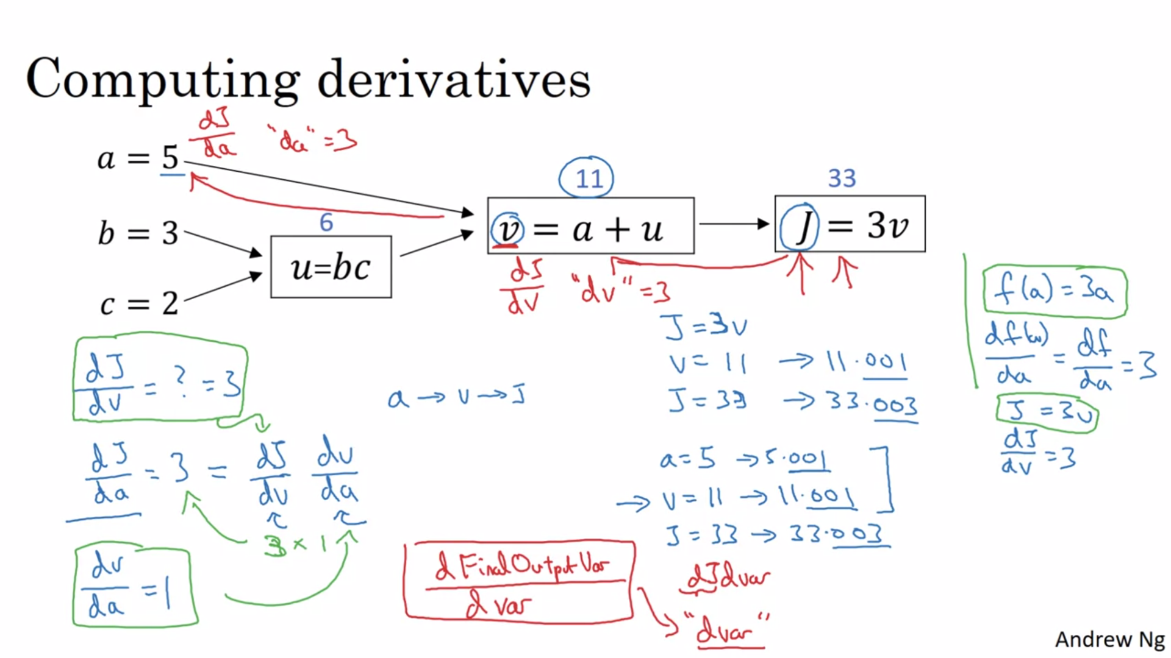

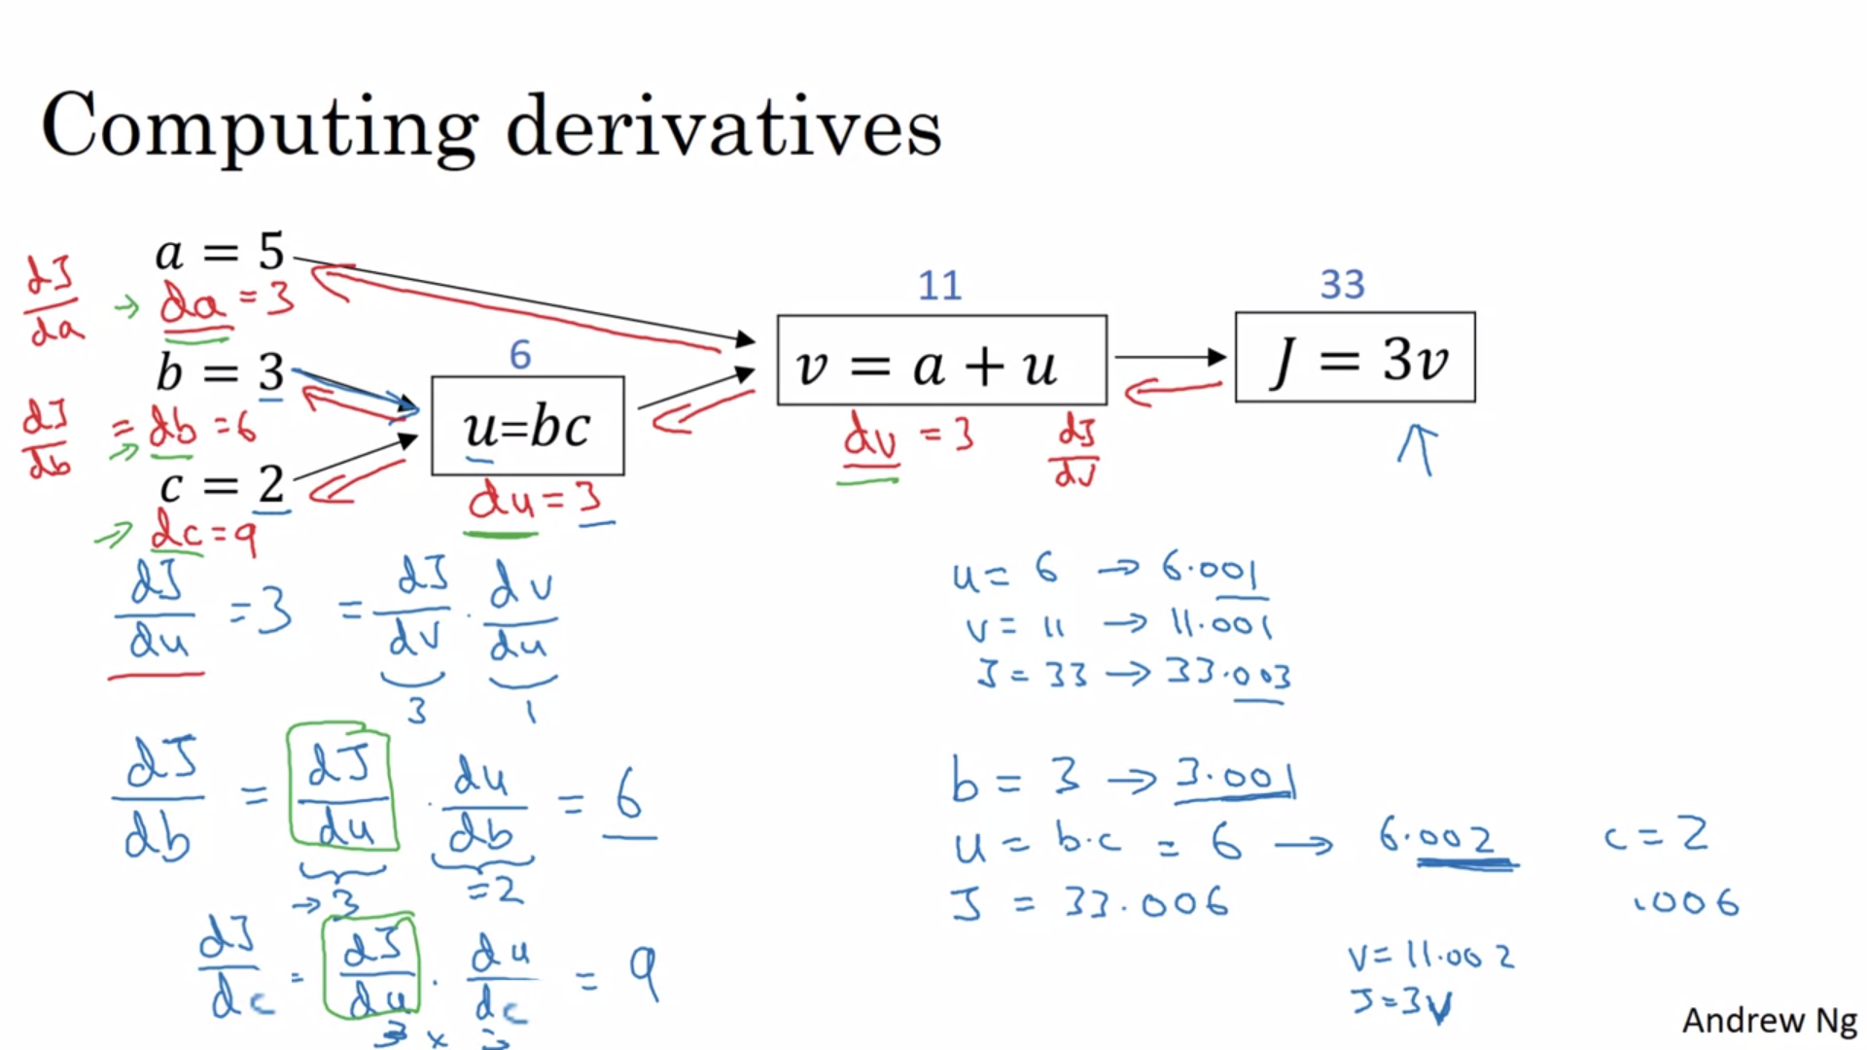

Back propagation on a computation graph can help calculate derivatives whereas the forward propagation can help calculate value of function such as J here.

# Logistic Regression Gradient Descent

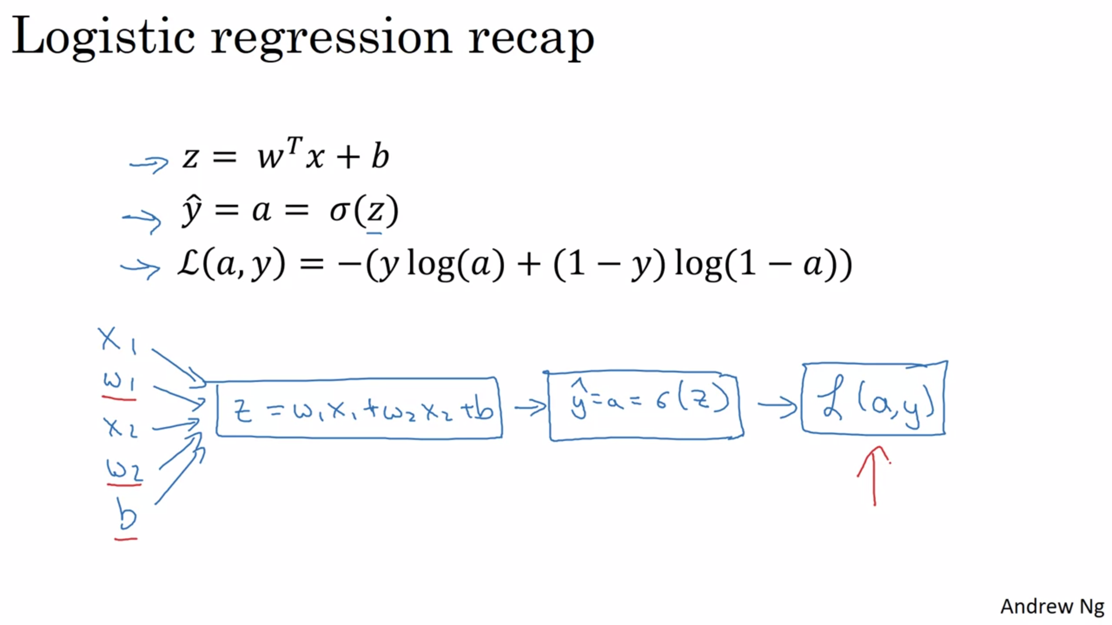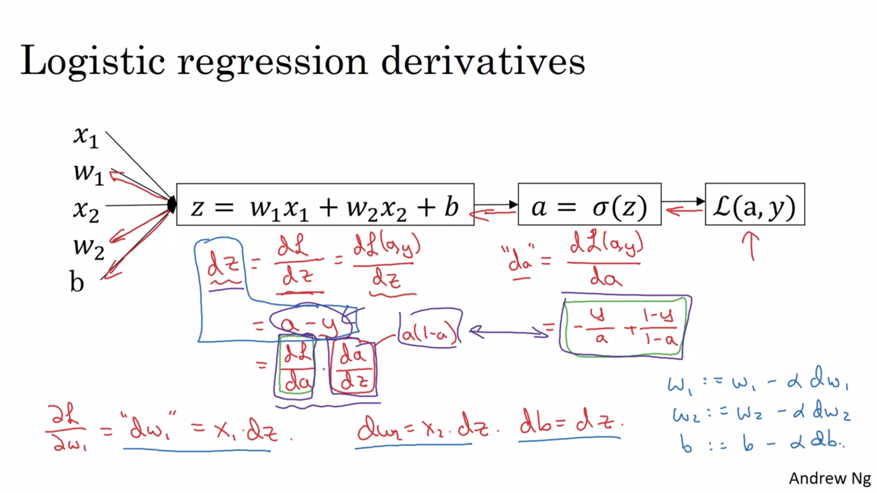

# Gradient Descent on m Examples

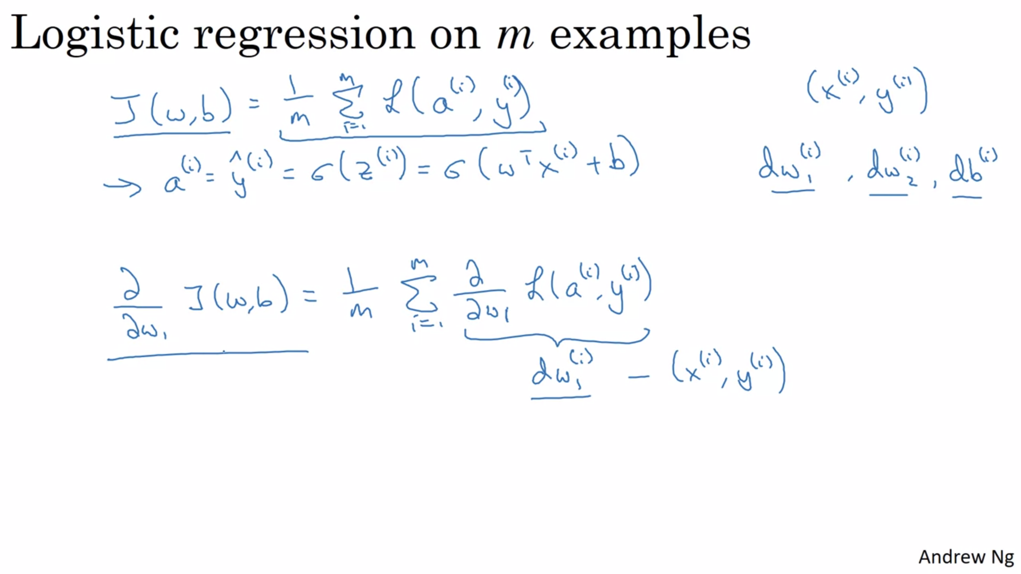

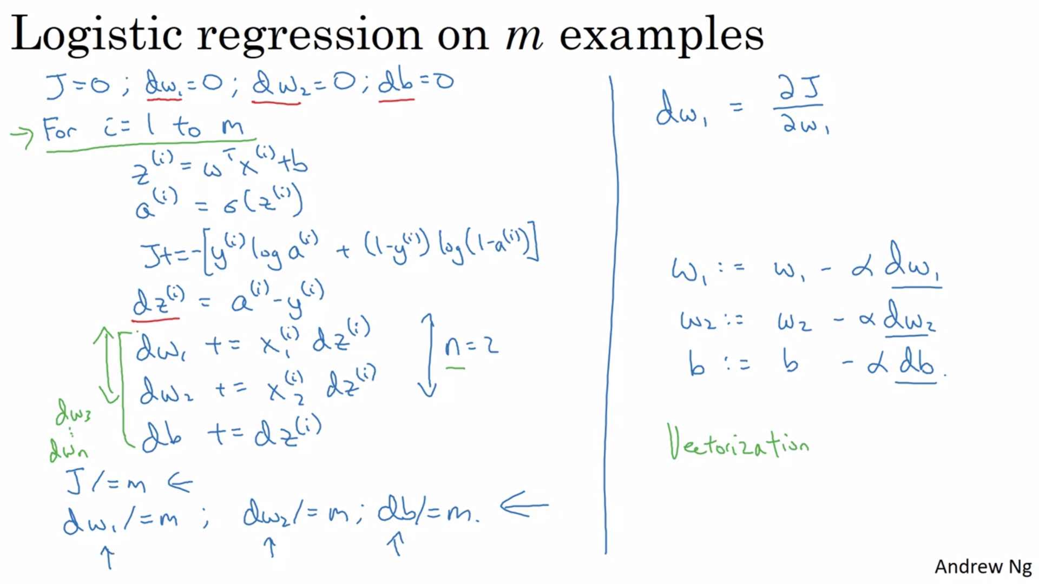

# Vectorization

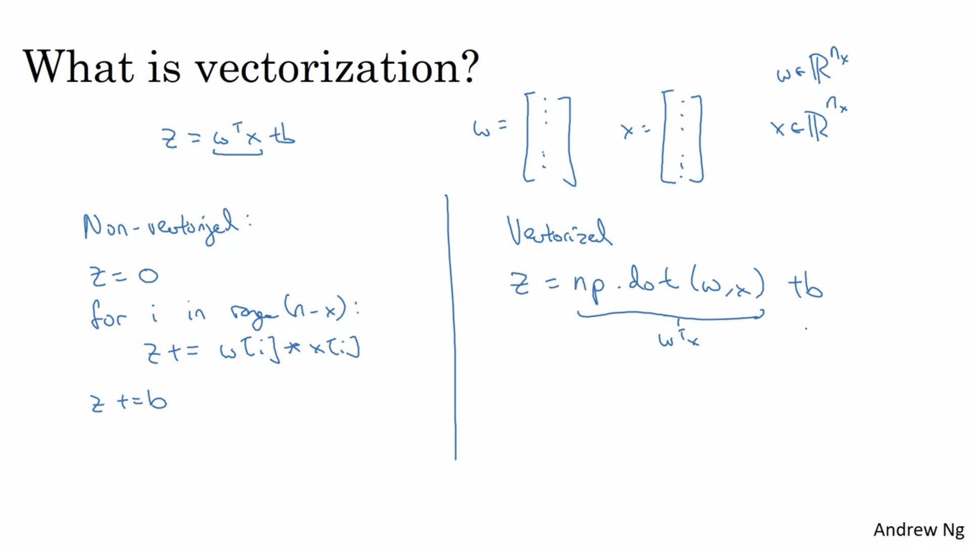

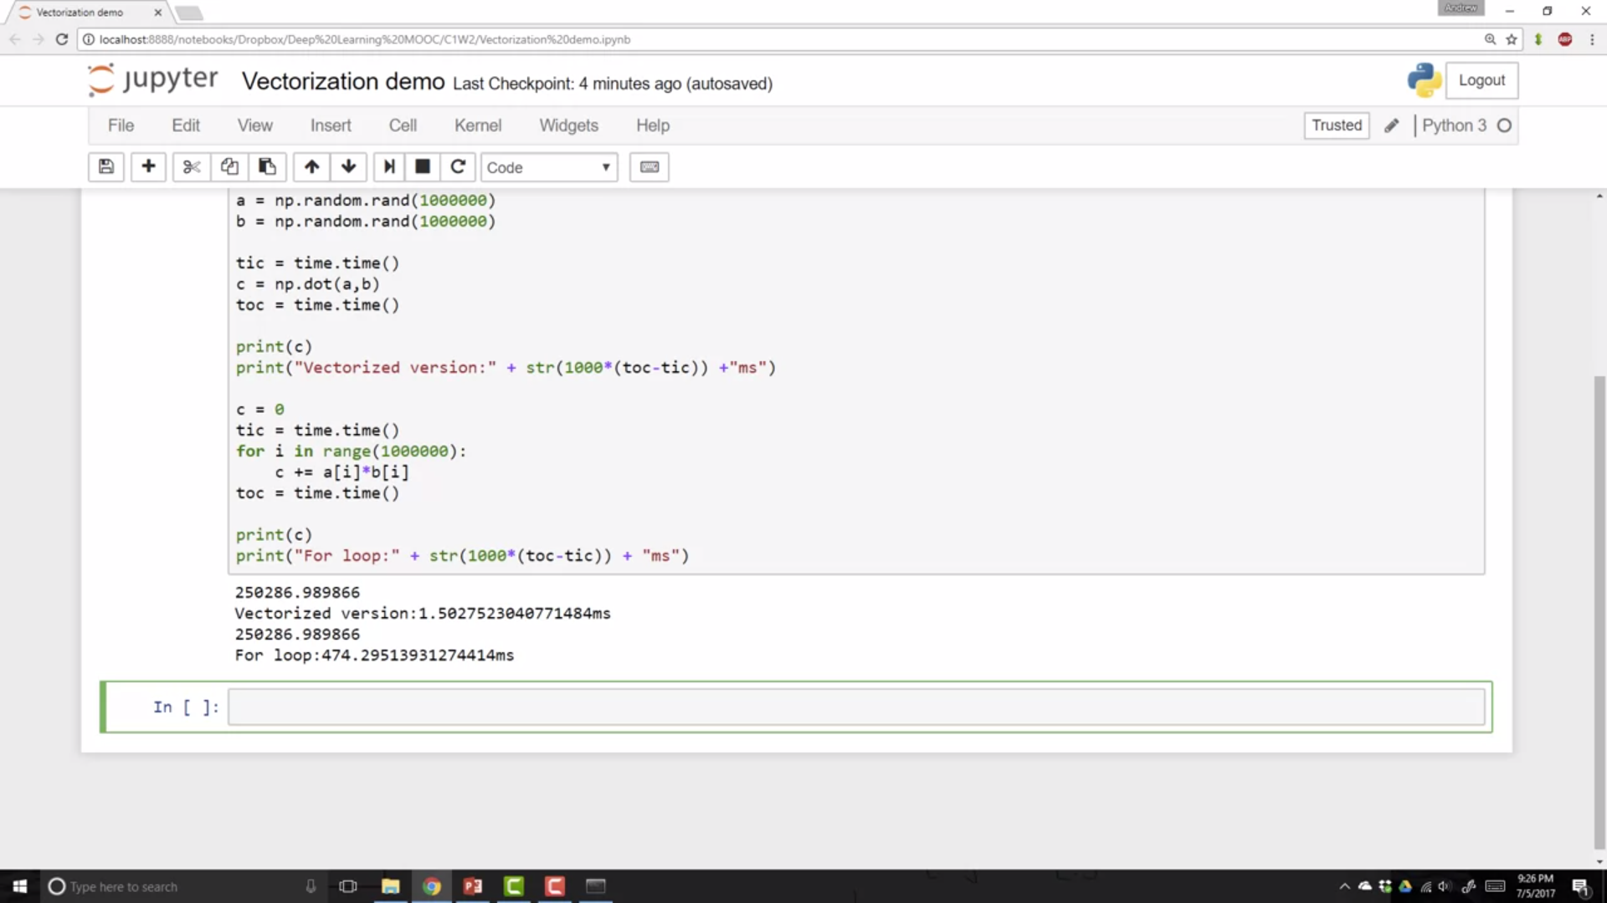

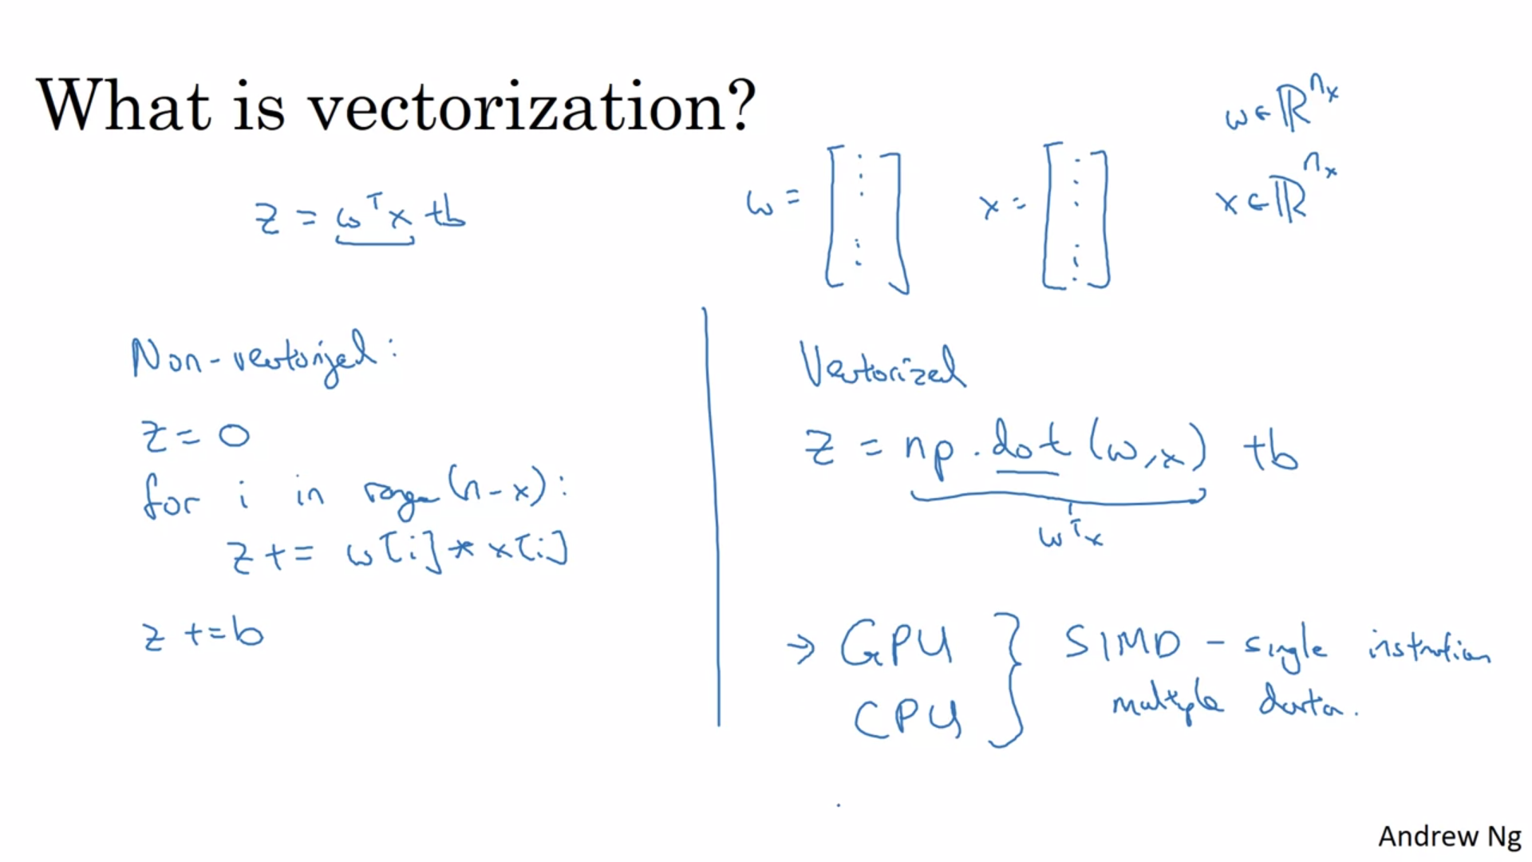

SIMD means that if we use inbuilt functions to perform operations such as numpy .dot() method, then CPU or GPU can take advantage of parallelization technique.

# More vectorization examples

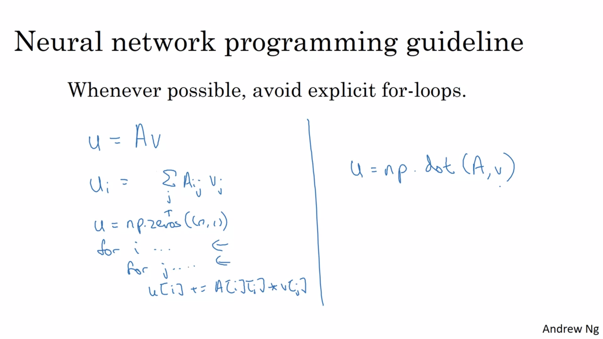

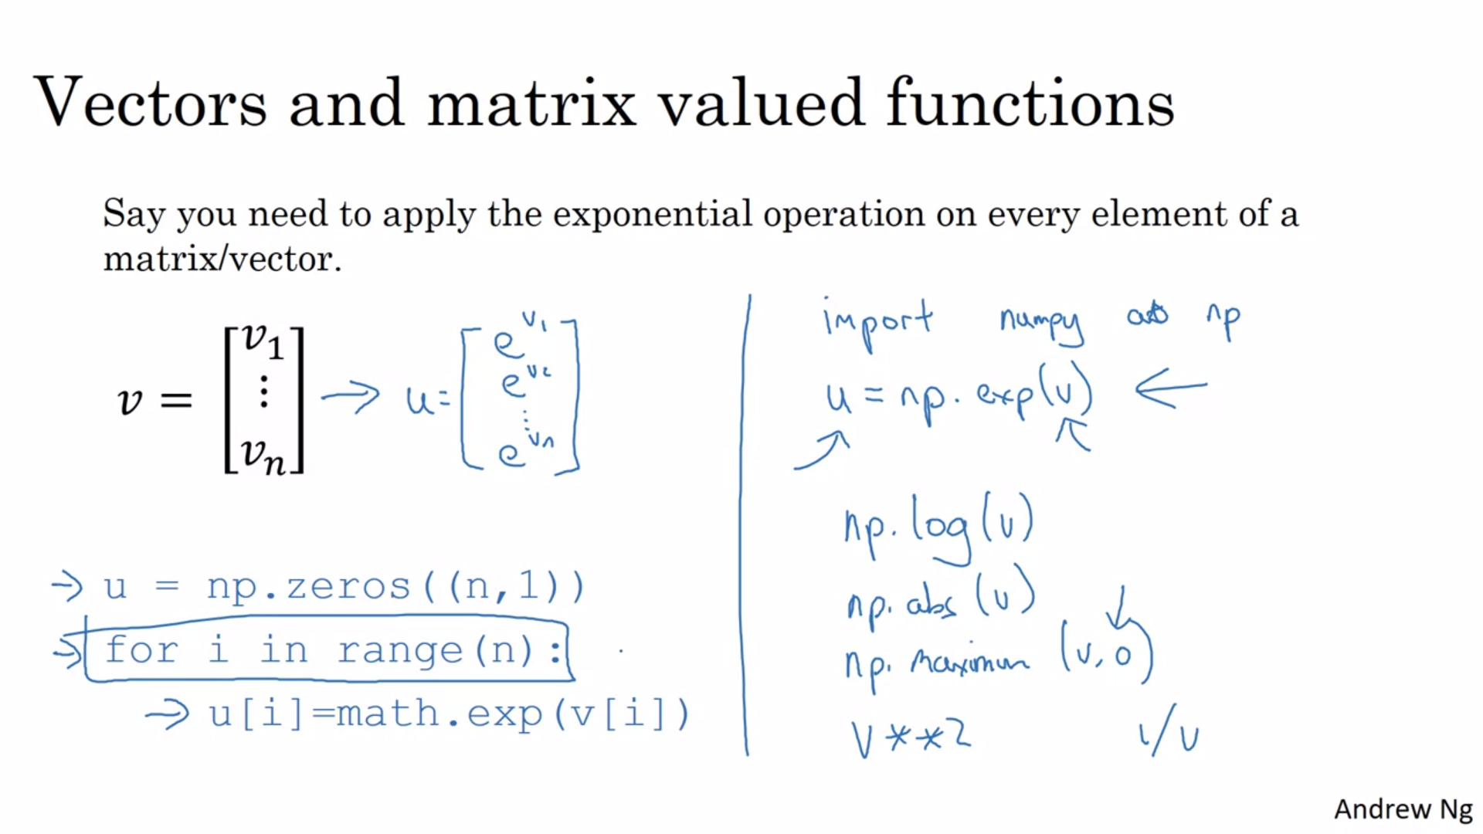

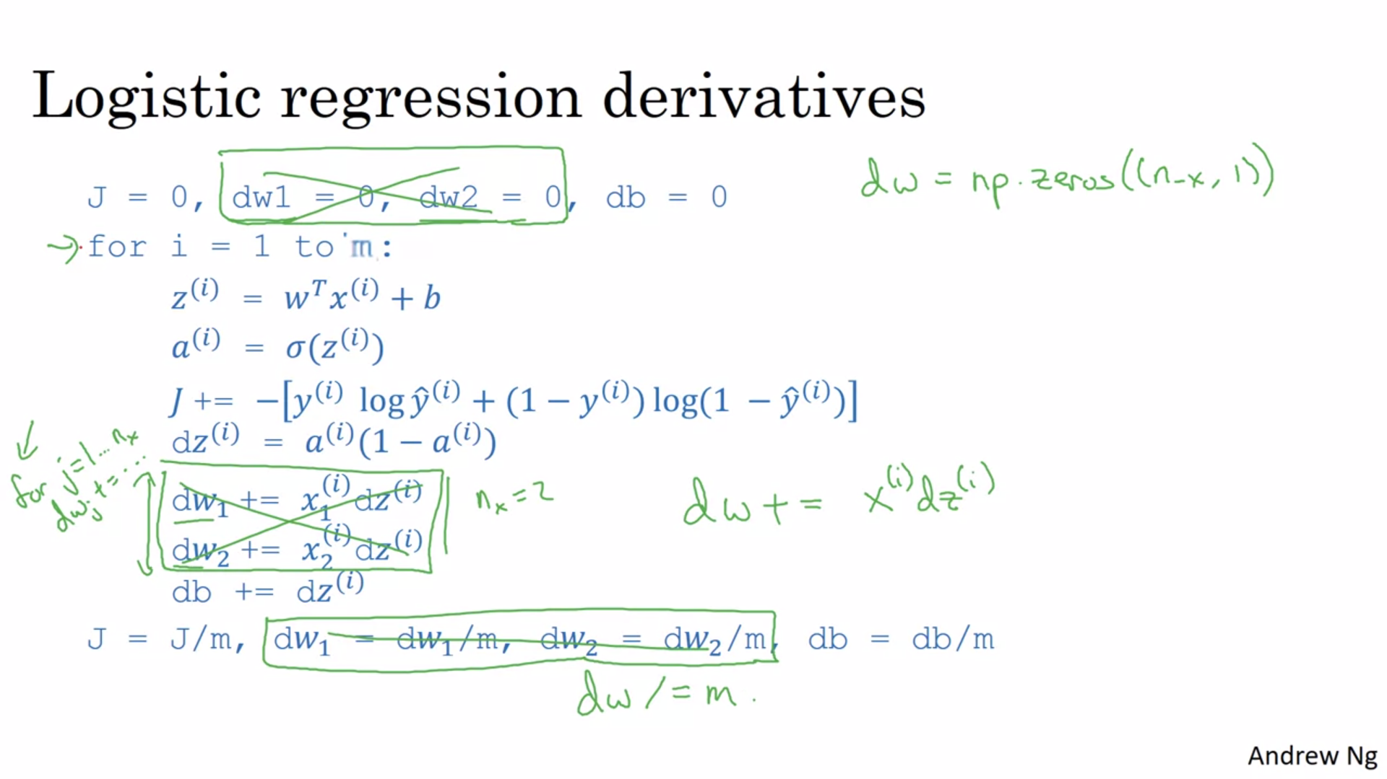

# Vectorizing Logistic Regression

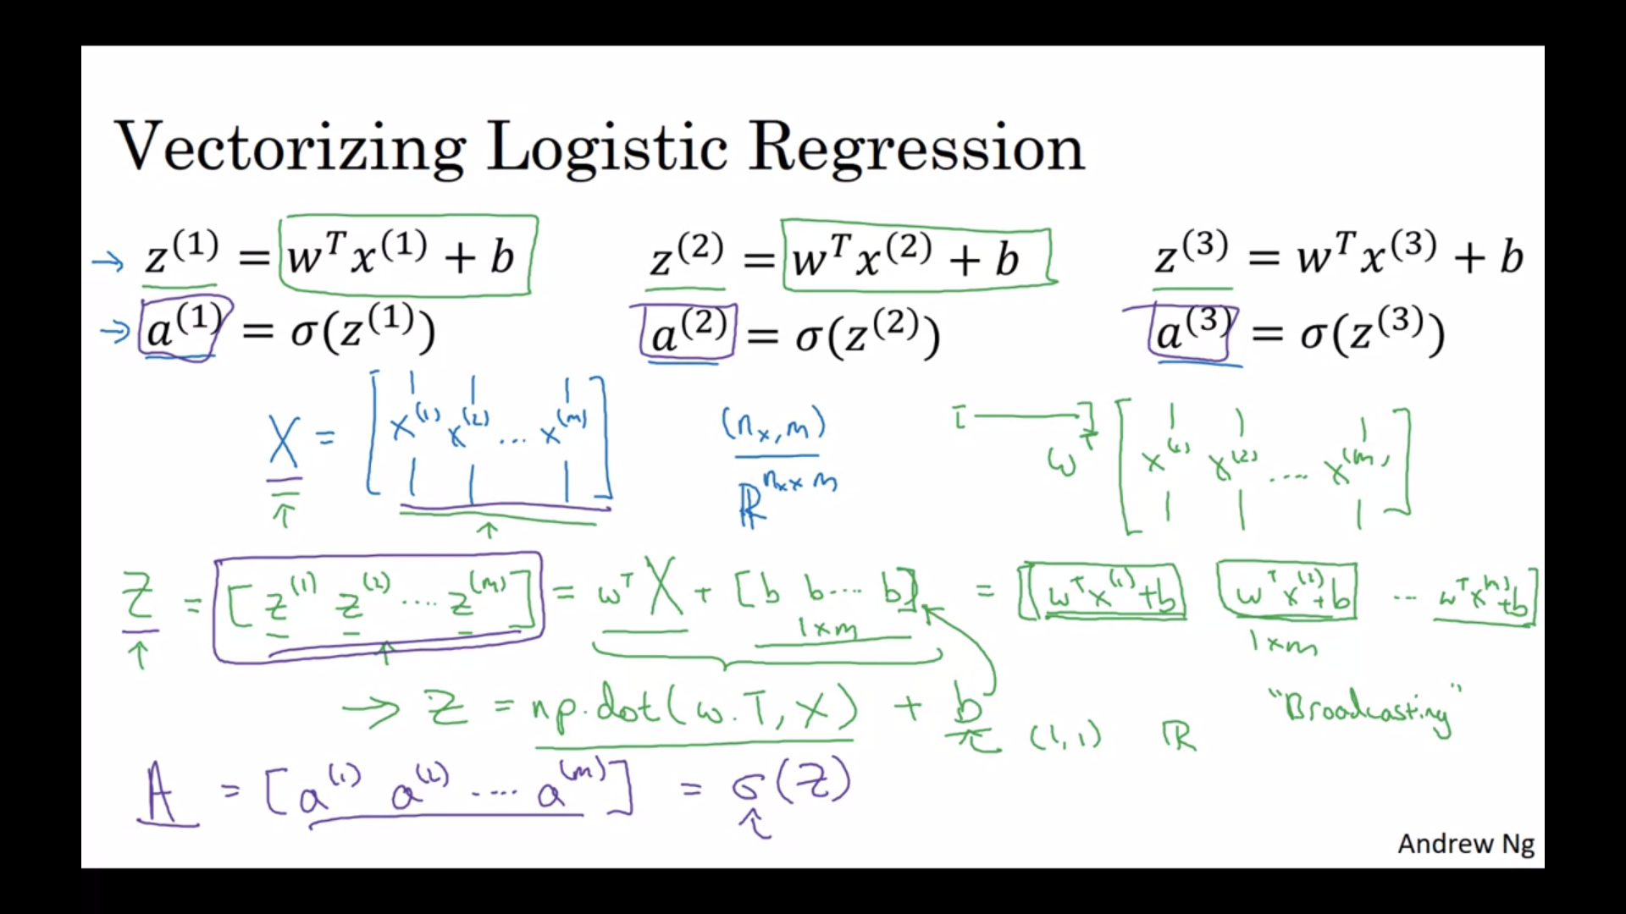

# Vectorizing logistic regression’s gradient output

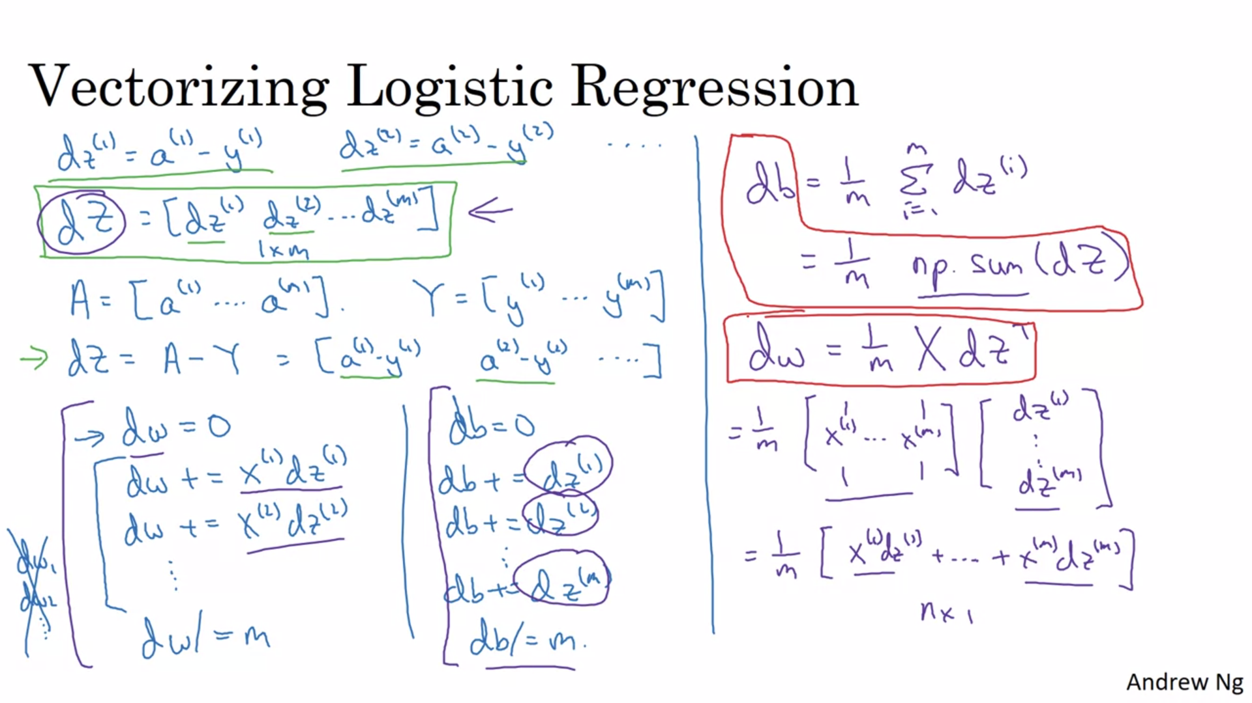

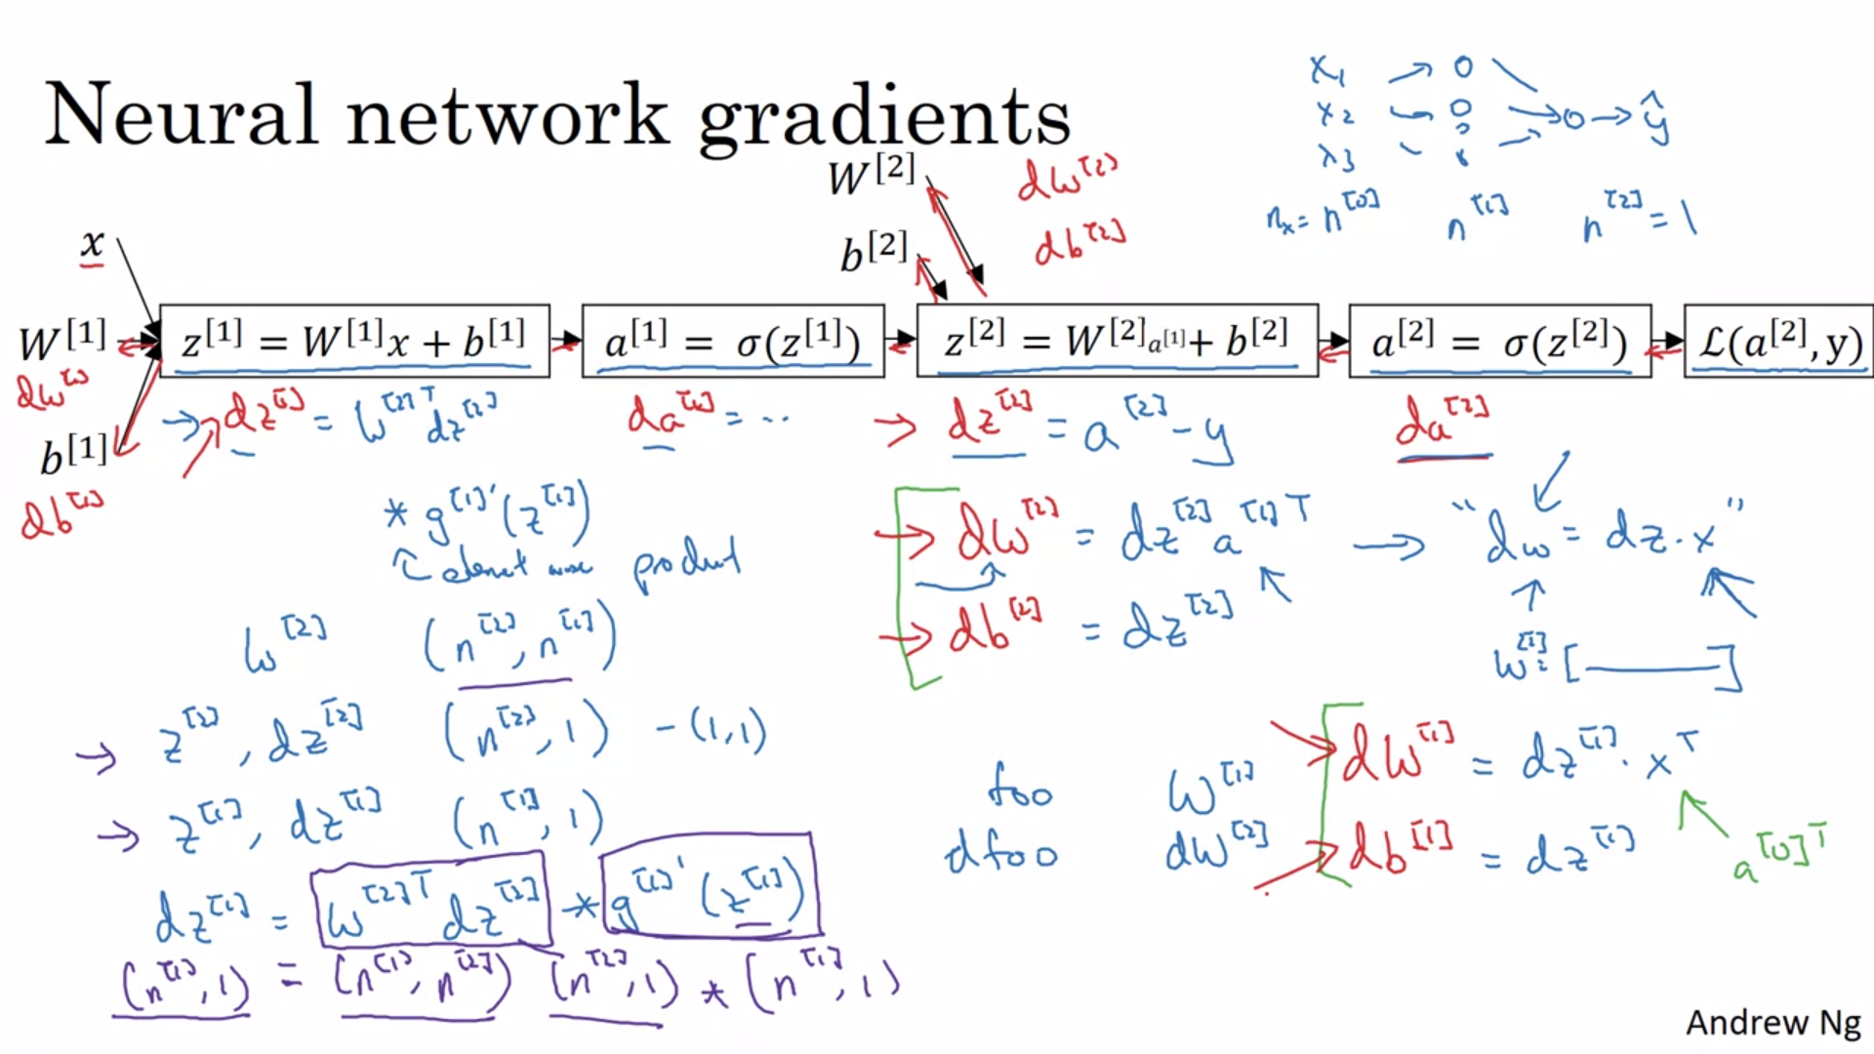

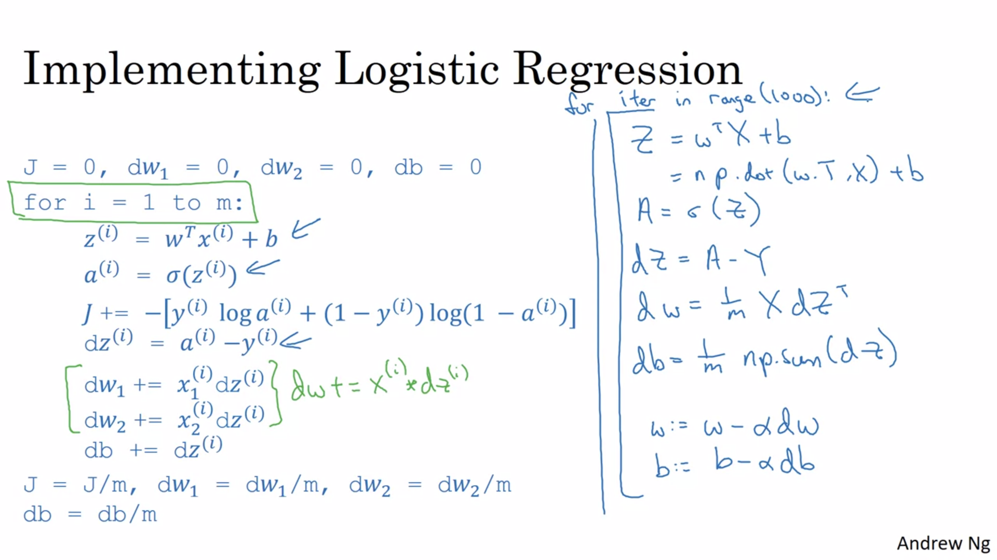

# Note on python on reducing errors

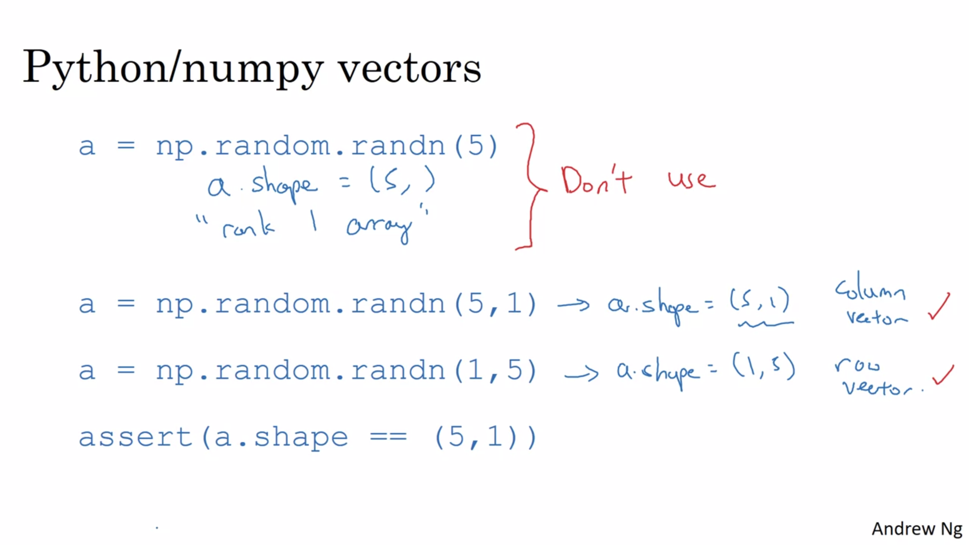

# Explanation of logistic regression cost function

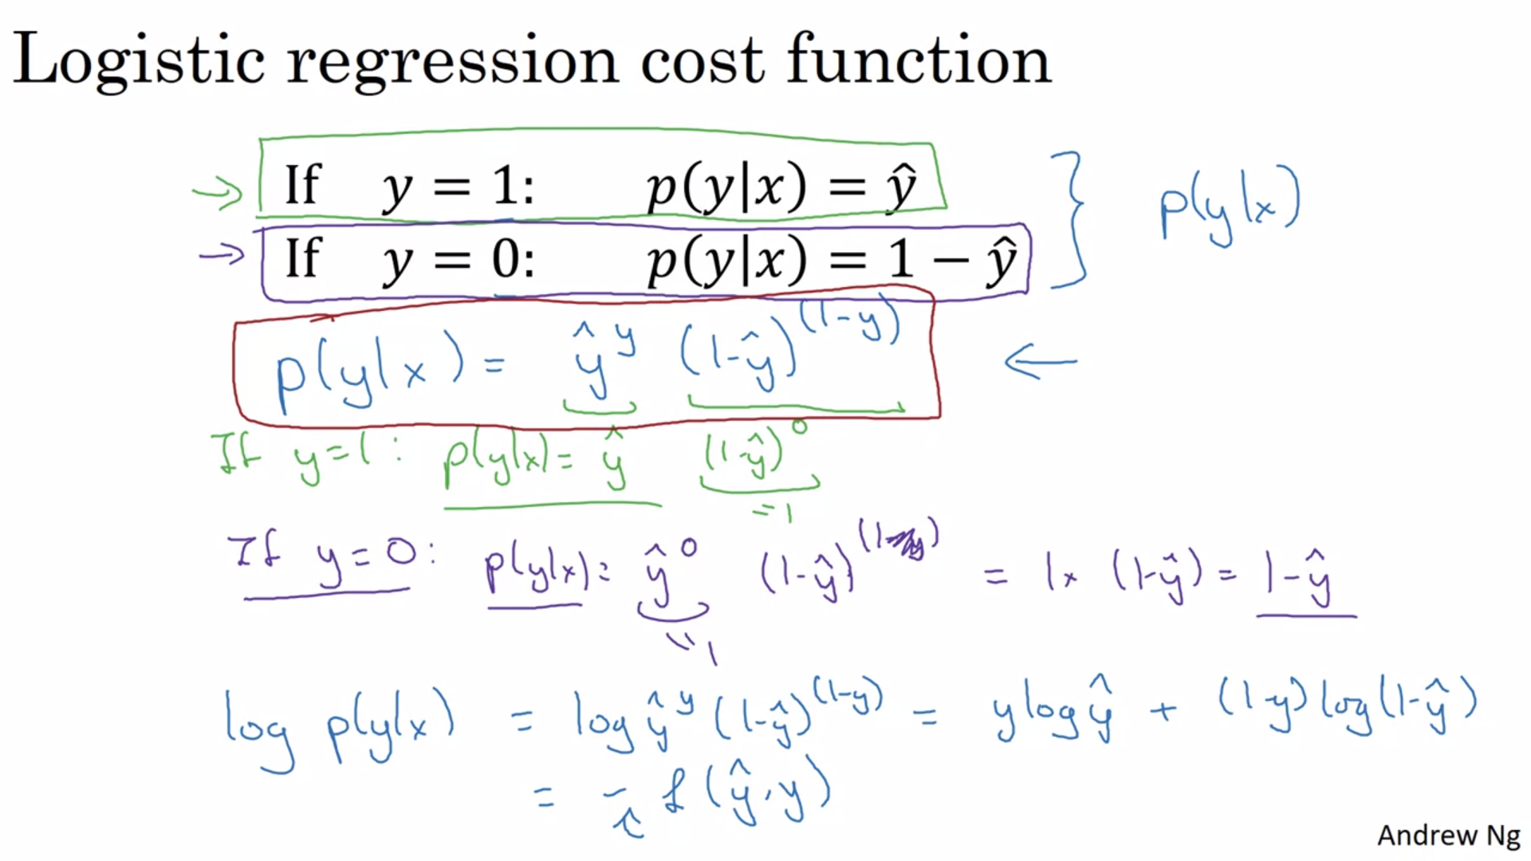

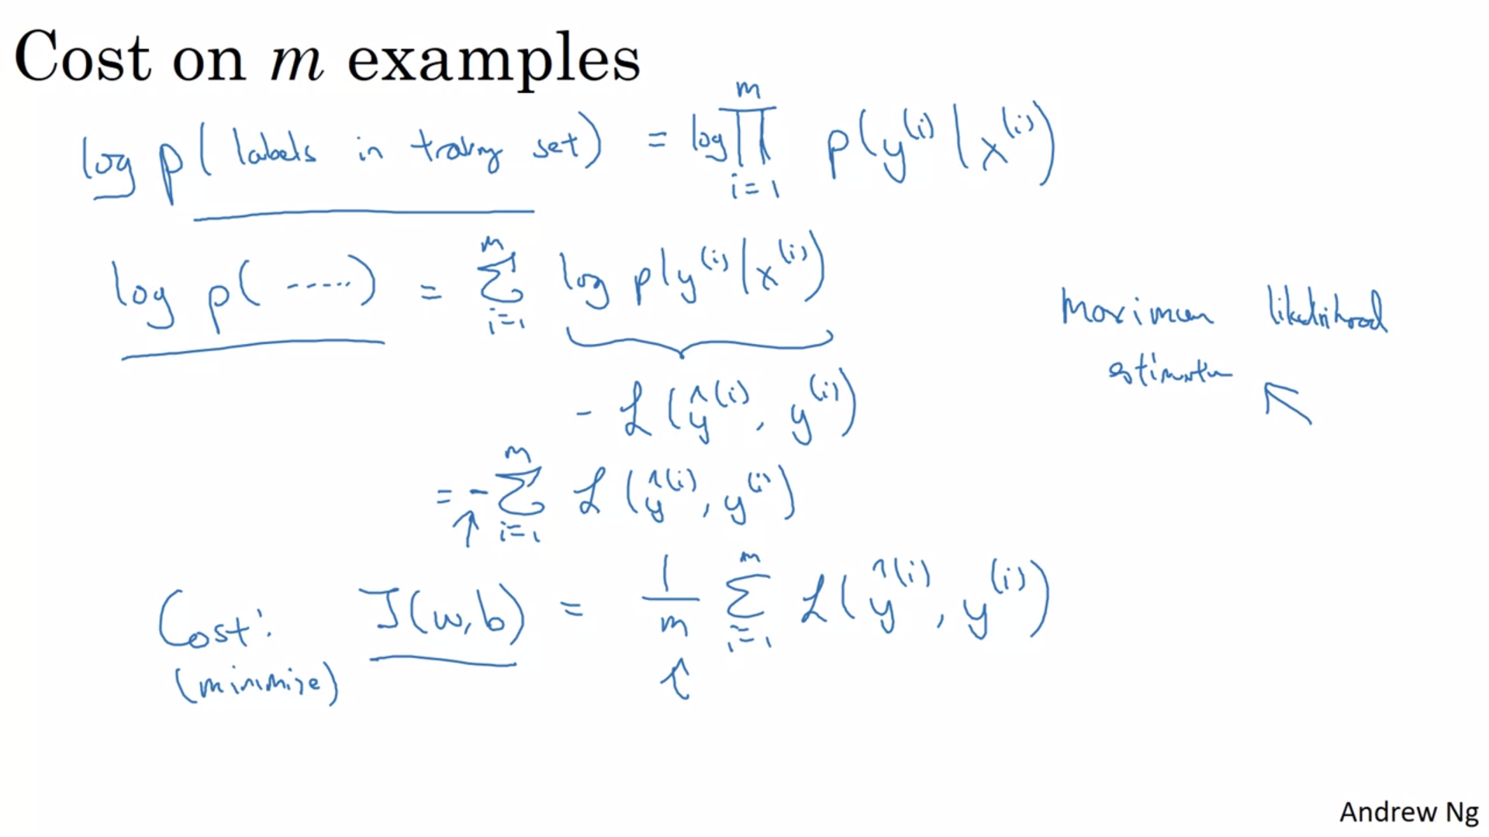

[h5py](http://www.h5py.org/) is a common package to interact with a dataset that is stored on an H5 file.

[PIL](http://www.pythonware.com/products/pil/) and [scipy](https://www.scipy.org/) are used here to test your model with your own picture at the end.